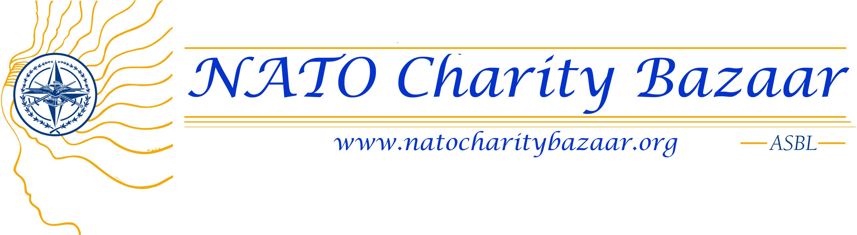

ORGANIZATION INFORMATION
Legal Name of organization: All-Ukrainian Public Association National Assembly of Persons with Disabilities of Ukraine (NAPD)
Mailing Address for Official Correspondence: Ukraine, Kyiv, 01034 Reytarska street 8/5-а, office 110
Email address: office@naiu.org.ua Web address: www.naiu.org.ua

ASBL No.: Exact Date established as an ASBL:

Name and title of Organization Contact Person: ^{Skrypka Nataliia,} Executive Director of the National Assembly of Persons with Disabilities of Ukraine
Contact Person Email Address office@naiu.org.ua
Contact Person Telephone Number: +38 044 279 61-74; 093-771-10-62
Languages Contact Person Can Speak: □ English □ French □ Flemish

Name of NATO CHARITY BAZAAR ASBL Member Contact:
Email Address: ______________________ Telephone Number: _________________________

Geographic Location of the Project (provide city, state and country): Ukraine

Focus of Project:
- Health  - Environment  - Education | - Women  - Children  - Seniors | - People with disabilities  - Other, please explain below

FINANCIAL INFORMATION

PROJECT BUDGET
Total Project Cost € 14 000,0
Will the Project be completed within a 12-month time frame? YES
If YES, Project time frame: June/2011 to December/2011
Amount Requested: € 9000,0
Are you approaching other funding sources for this project? ___YES ____ NO
If YES, for how much of the project budget? € 5000,0
If we can only fund part of the project, specify the smallest amount required to make this project viable: € 6000,0

PROPOSAL SUMMARY

Is the name of the Proposed Project different than the name of the Organization? __YES __ NO
If YES, what is the name of the Project? “Partnership for the Interests of Children”
State Your Organization’s Mission (2 sentences or less. Provide text in English and French. Application is considered incomplete if the information is not provided in both languages):

ENGLISH VERSION
The Mission of the National Assembly of Persons with Disabilities of Ukraine is the protection of the rights of people with disabilities, supporting their integration to the society; prevention of any forms of discrimination towards people with disabilities and violations of their rights.
FRENCH VERSION

Summarize the proposed project (4 sentences or less. Provide this text in English and French. Application is considered incomplete if the information is not provided in both languages).

ENGLISH VERSION
This project is called to ensure high quality rehabilitation services for the children with disabilities who are brought up at two internats through procurement and establishment of the sensory rooms. Children with severe impairments brought up at the state residential care institutions cannot have high quality rehabilitation due to lack of funding provided for these institutions. This leads to progression of the illnesses and makes further rehabilitation more difficult. Establishment of the sensory rooms at two internats (out of total 56 in Ukraine) will give an opportunity to help to 270 children.

FRENCH VERSION

Attach 2 digital photographs of your organization and its work. If your organization is deemed eligible for funding, these pictures will appear on our web site.
Picture related to the project on ensuring the right of children with disabilities for education
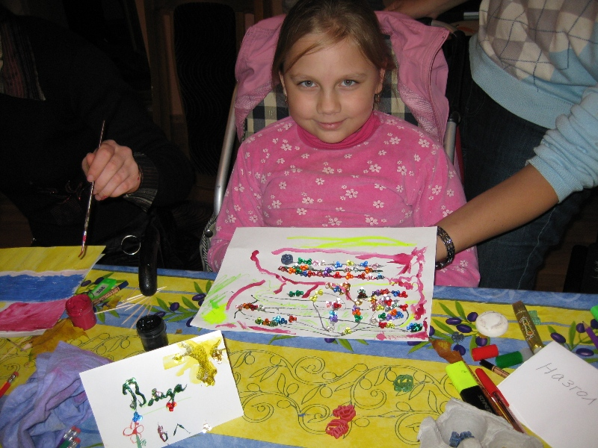
Picture related to the project on provision of quality services for children with disabilities at the internats
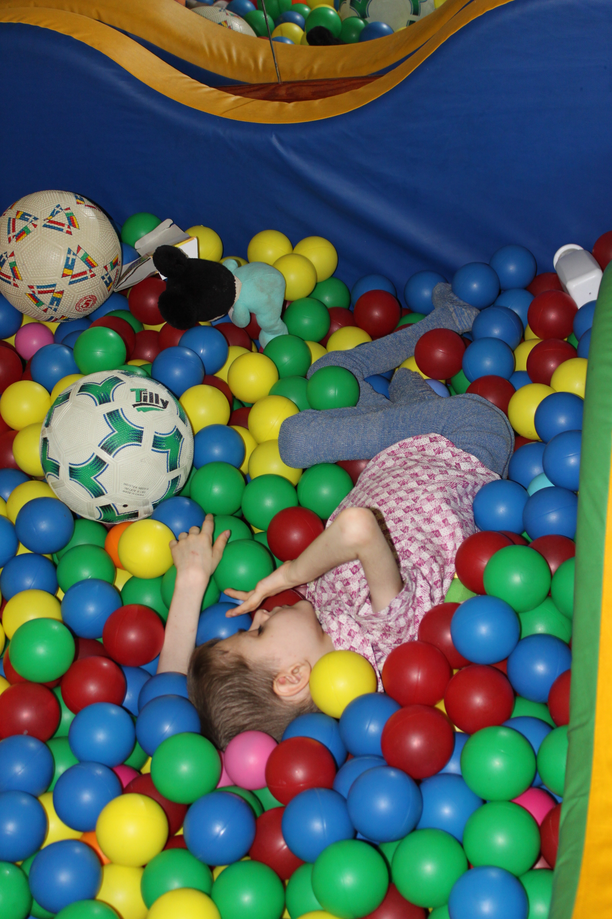

FUNDING PROPOSAL NARRATIVE & ATTACHMENTS

I. Organization Information
1. Brief Summary of Organization’s history and mission.

National Assembly of Persons with Disabilities of Ukraine (NAPD) was founded on September, 22, 2001 with the purpose of uniting public organizations the members of which are people with disabilities.
For the time being 81 public organizations are the members of NAPD which present people with disabilities of different nosologies from all areas of Ukraine ( about 1.9 million citizens).

Basic tasks of NAPD:
- assistance and participating in forming of public policy on working out social problems of people with disabilities and providing of their rights
- assistance in the integration of people with disabilities into the society, prevention of all forms of discrimination towards people with disabilities and violation of their rights
- assistance in forming of the society consciousness as to positive attitude towards citizens with disabilities
2. Description of current programs, activities, and strengths/accomplishments (highlighting the past year), including what makes your organization unique.
Implementing its regular activities, NAPD carries out 12 long-term All-Ukrainian programs, in particular:
- Participating in forming of public policy in the sphere of social defense of people with disabilities;
- Strengthening of the ability of public organizations of people with disabilities, forming of civil society;
- Creation of unlimited access of people with physical disabilities to the objects of housing and public setting in Ukraine;
- Development and forming of public movement of young people with disabilities;
- Legal education and defense of rights of people with disabilities;
- Introduction of an inclusive and integrated education «Education for everybody» and others
National Assembly of Persons with Disabilities of Ukraine implements international projects related to ensuring the rights of children with disabilities.
- 2008-2013 – Ukrainian-Canadian project «Inclusive Education for Children with Special Needs in Ukraine»
- 2009-2011р Improving the quality of life and standards of services for children with severe disabilities in Ukraine” (Matra Project).

National Assembly of Persons with Disabilities of Ukraine is the united coalition of public organizations, which is defined in legislatively normative documents ( especially in President's Decrees and Decisions, Orders of the Government) as organization which can ensure an expert estimation and monitoring of the legislation of Ukraine in a social sphere.
Due to paying much attention to the increase of professional level of the members - leaders of public organizations of people with disabilities, NAPD was able to obtain that:
- The representatives of NAPD (people with disabilities) became advisers in social questions of heads of regional administrations in most areas of Ukraine;
- The representatives of NAPD are the members of commissions of types and working groups of central, regional; municipal and local authority bodies;
- The representatives of NAPD are the members of working groups in the issues of improvement of legislatively normative base of ministries of types.

Three the most important achievements during last years
1. Organizing the campaign of advocacy directed on signing and ratification of UNO's Convention about Rights for Persons with Disabilities and Optional protocol to it by Ukraine.
Result: The Convention is signed by Ukraine on September, 24, 2008, ratified by Ukraine on December, 16, 2009.
2. Introduction of the program "Ukraine without barriers".

Result: Due to permanent public monitoring, implementation of activity control of executive power bodies for 2 years accessibility to the objects of social and transport infrastructure of people with disabilities and limited-mobile groups of population on all territory of Ukraine was considerably improved. The Program "Ukraine without barriers" was accepted by the Government of Ukraine in July, 2009.

3.Implementation of Inclusive Education in Ukraine.
Result: first schools opened their doors for children with disabilities (2010).

II. Purpose of Funding Request
- Please explain your need for support and also the impact this support will have.

In 2008 році National Assembly of Persons with Disabilities (NAPD) in cooperation with other public organizations has initiated all-Ukrainian program called to change the existing system of bringing-up and maintenance of children with disabilities who lack the opportunity to grow in families and are placed at the state social institutions. The first steps within the program were related to implementation of:
- the project «Improving Quality of Life and Standards of Services for Disabled Children through Development and Strengthening of Civil Society in Ukraine» supported by MATRA Programme of the Kingdom of Netherlands Government. The project was implemented at the three pilot regions of Ukraine. As of today, it is planned to apply project results (staff training, changing the system of service delivery, legal initiatives etc.) to all the existing internats subordinate to the Ministry of Social Policy of Ukraine (56 internats for children);
- the project «Monitoring of Observance of the Rights of Children with Disabilities in the Internats for Children Subordinate to the Ministry of Social Policy» supported by the International Renaissance Foundation;
- the project on recovery of children with severe hypotrophy.
This project «Partnership for the Interests of Children» is a part of the programme implemented by NAPD and is called to improve the situation with quality provision of services for children with disabilities.
It is planned to procure equipment for sensory rooms at two internats. This will give the opportunity to the staff of the institutions to provide comprehensive rehabilitation of the children with disabilities.
All the equipment is certified in Ukraine.
In the frames of the existing program National Assembly of Persons with Disabilities will hold the training for the staff of the institutions on application of the sensory rooms.
Financial support of this project is important and necessary, since as of today social sphere is funded by the state on leftovers, and this means that very many children with severe impairments receive less quality services.

- List the Proposal’s Target Population. In other words, Exactly who and how many people will benefit from this project?

Children with disabilities (270 persons) brought up at two 2 internats of the Ministry of Social Policy of Ukraine.

III. Itemization of Project Budget
- Provide an itemized budget for the project.
9 000,0 - equipment sensory rooms (2 internats)
5 000,0- repair rooms (2 internats)

- Please indicate your order of importance for funding, if there are separate parts to the project.

IV. Attachments (If possible, all attachments should be in English and/or French)
- Bank statement giving official details of the bank account, including IBAN, BIC, SWIFT codes or ABA/Routing Transit Number (USA). No donation shall be made to a personal account.
- Organization statutes.
- Annual financial report.

